Perth Academy

S3 Physics
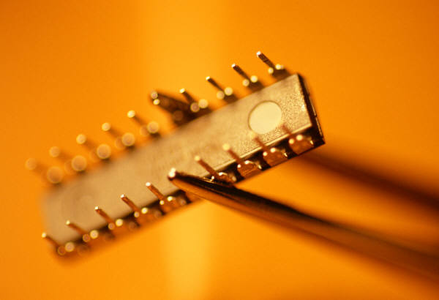
Basic Electronics
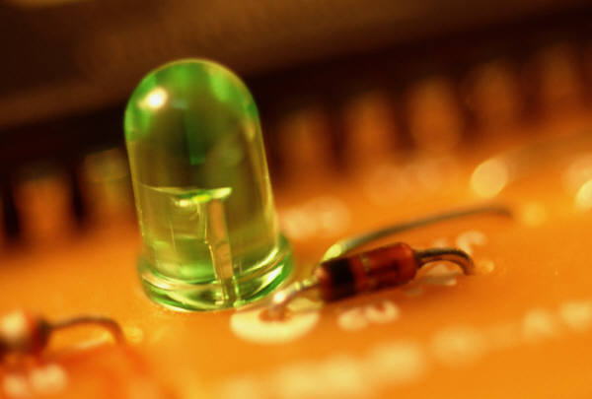
Pupil Booklet
- Learning Outcomes
- Homework
- Summary
SCN 4-09b
By contributing to investigations into the properties of a range of electronic components, I can select and use them as input and output devices in practical electronic circuits.

SCN 4-09c
Using my knowledge of electronic components and switching devices, I can help to engineer an electronic system to provide a practical solution to a real-life situation.

How Confident am I with the Learning Outcomes?

- Circle the faces to keep a record of your progress.

I am confident that I understand this and I can apply this to problems
I have some understanding but I need to revise this some more
I don’t know this or I need help because I don’t understand it

- You can use this to help you pick the areas of the unit that need the most revision.
- As you revise your class work you will be able to circle more and more smiley faces.
- If that does not help then you should ask your teacher!
Learning Outcomes | Can you do this? | Comments
Electronic Systems
- State that an electronic system consists of three parts: input, process and output.
- Identify from a diagram the input, process and output subsystems of an electronic system.
- Draw a block diagram showing the input, process and output subsystems of an electronic system.
- Distinguish between digital and analogue outputs.
- Identify analogue and digital signals from waveforms viewed on an oscilloscope.

Input Devices
- State that the microphone, thermistor, LDR, switch and solar cell are examples of input devices.
- State the energy changes associated with these input devices.
- State that the resistance of a thermistor changes with temperature.
- State that the resistance of an LDR decreases as light gets brighter.
- Identify from a list an appropriate input device for a given application.
- Carry out calculations using voltage, current and resistance for the thermistor and the LDR.
Output Devices
- Give examples of output devices and the energy conversions involved.
- State that a buzzer, loudspeaker, lamp, LED, electric motor relay, solenoid and 7 segment display are examples of output devices.
- Draw and identify the symbol for these output devices.
- State that an LED will light only if connected one way round.
- Explain the need for a series resistor with an LED.
- State that different numbers can be produced by lighting appropriate segments of a 7 segment display.

Process Devices
- Draw and identify the symbols for two input AND and OR gates, and a NOT gate.
- State that:
High voltage = logic 1
Low voltage = logic 0
- State that for a NOT gate the output is the opposite of the input.
- State that for an AND gate both inputs must be high for the output to be high.
- State that for an OR gate either input must be high for the output to be high.
- State that logic gates may have one or more inputs and that a truth table shows the output for all possible input combinations.
- Draw the truth tables for two input AND and OR gates, and a NOT gate
- Explain how to use combinations of digital logic gates for control in simple situations.

