**Perth Academy**

**S3 Physics**

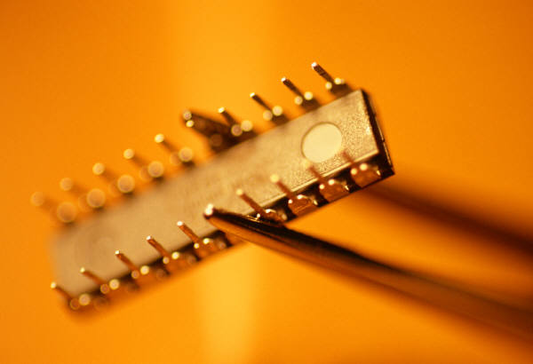

**Basic Electronics**

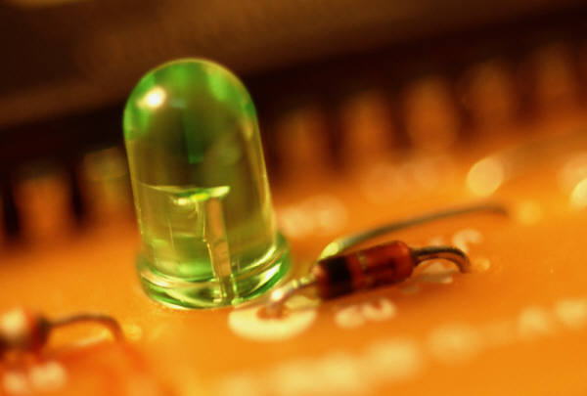

**Pupil Booklet**

* Learning Outcomes
* Homework
* Summary

SCN 4-09b

By contributing to investigations into the properties of a range of electronic components, I can select and use them as input and output devices in practical electronic circuits.

SCN 4-09c

Using my knowledge of electronic components and switching devices, I can help to engineer an electronic system to provide a practical solution to a real-life situation.

**How Confident am I with the Learning Outcomes?**

* Circle the faces to keep a record of your progress.

☺ I am confident that I understand this and I can apply this to problems

😐 I have some understanding but I need to revise this some more

☹ I don’t know this or I need help because I don’t understand it

* You can use this to help you pick the areas of the unit that need the most revision.
* As you revise your class work you will be able to circle more and more smiley faces.
* If that does not help then you should ask your teacher!

|  |  |  |
| --- | --- | --- |
| **Learning Outcomes** | **Can you do this?** | **Comments** |
| **Electronic Systems** |  |  |
| 1. State that an electronic system consists of three parts: input, process and output. | ☹ 😐 ☺ |  |
| 1. Identify from a diagram the input, process and output subsystems of an electronic system. | ☹ 😐 ☺ |  |
| 1. Draw a block diagram showing the input, process and output subsystems of an electronic system. | ☹ 😐 ☺ |  |
| 1. Distinguish between digital and analogue outputs. | ☹ 😐 ☺ |  |
| 1. Identify analogue and digital signals from waveforms viewed on an oscilloscope. | ☹ 😐 ☺ |  |

|  |  |  |  |
| --- | --- | --- | --- |
| **Input Devices** |  | |  |
| 1. State that the microphone, thermistor, LDR, switch and solar cell are examples of input devices. | ☹ 😐 ☺ | |  |
| 1. State the energy changes associated with these input devices. | | ☹ 😐 ☺ |  |
| 1. State that the resistance of a thermistor changes with temperature. | | ☹ 😐 ☺ |  |
| 1. State that the resistance of an LDR decreases as light gets brighter. | | ☹ 😐 ☺ |  |
| 1. Identify from a list an appropriate input device for a given application. | | ☹ 😐 ☺ |  |
| 1. Carry out calculations using voltage, current and resistance for the thermistor and the LDR. | | ☹ 😐 ☺ |  |
| **Output Devices** | |  |  |
| 1. Give examples of output devices and the energy conversions involved. | | ☹ 😐 ☺ |  |
| 1. State that a buzzer, loudspeaker, lamp, LED, electric motor relay, solenoid and 7 segment display are examples of output devices. | | ☹ 😐 ☺ |  |
| 1. Draw and identify the symbol for these output devices. | | ☹ 😐 ☺ |  |
| 1. State that an LED will light only if connected one way round. | | ☹ 😐 ☺ |  |
| 1. Explain the need for a series resistor with an LED. | | ☹ 😐 ☺ |  |
| 1. State that different numbers can be produced by lighting appropriate segments of a 7 segment display. | | ☹ 😐 ☺ |  |

|  |  |  |
| --- | --- | --- |
| **Process Devices** |  |  |
| 1. Draw and identify the symbols for two input AND and OR gates, and a NOT gate. | ☹ 😐 ☺ |  |
| 1. State that:   High voltage = logic 1  Low voltage = logic 0 | ☹ 😐 ☺ |  |
| 1. State that for a NOT gate the output is the opposite of the input. | ☹ 😐 ☺ |  |
| 1. State that for an AND gate both inputs must be high for the output to be high. | ☹ 😐 ☺ |  |
| 1. State that for an OR gate either input must be high for the output to be high. | ☹ 😐 ☺ |  |
| 1. State that logic gates may have one or more inputs and that a truth table shows the output for all possible input combinations. | ☹ 😐 ☺ |  |
| 1. Draw the truth tables for two input AND and OR gates, and a NOT gate | ☹ 😐 ☺ |  |
| 1. Explain how to use combinations of digital logic gates for control in simple situations. | ☹ 😐 ☺ |  |

**Elective Homework – Getting Started**

Success involves doing many kinds of problems which help improve your knowledge and understanding of the ideas in the course and your ability to solve problems. To get started we will look at a general method for tackling problems.

General Method for Solving Problems.

Any numerical problem in Physics can be solved using the following steps:

* Read the question carefully.
* Find out exactly what is being asked.
* Extract the key data.
* Select the correct equation.
* Substitute the data into the equation and find the missing variable.
* Give the answer and correct unit.

**Example**

**How far does a cyclist travel in 26 seconds if she is travelling at a constant speed of 8 metres per second?**

Solution

Read the question carefully

Find out exactly what is being asked Distance (how far)

Extract the key data time = 26 seconds

speed = 8 metres per second

Select the correct equation distance = speed x time

Substitute data into equation d = 8 x 26

Give the answer and correct unit d = 208 m

Usual Layout

|  |  |
| --- | --- |
| d = ?  v = 8 m/s  t = 26 s | d = v x t  = 8 x 26  = 208 m |

**All numerical questions in the following homework exercises should be carried out in this way. No marks will be awarded for an answer given without the working being shown.**

Helpful Hint

Always watch the units in an equation. They may need to be converted **before** being put into an equation.

e.g. 3 mA = 0.003 A = 3 x 10-3 A

6 km = 6000 m = 6 x 103 m

Homework Exercise 1 – Electronic Systems.

You will find help with this exercise on page 12.

1. Complete the block diagram below to illustrate the parts of an electronic system.

# input

(2)

1. Street lights come on automatically when it gets dark. A light sensor detects the light level, and a voltage controlled switch turns on a lamp when it gets dark enough.

Show this system in a block diagram. (3)

1. Study these two oscilloscope screens.

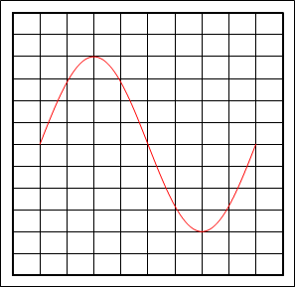

**A**

**B**

(a) State which one represents an analogue output and which a digital output. (1)

Total (6)

Put your answers to homework exercise 1 here.

Homework Exercise 2 – Input Devices (page 1).

You will find help with this exercise on pages 13 and 14.

1. Copy and complete the following table:

|  |  |
| --- | --- |
| Input Device | Energy Change |
| solar cell | 🡪 |
|  | sound 🡪 electrical |

(2)

2. Use the following list of input devices to choose the most

appropriate input for the systems given below:

microphone, thermistor, LDR, switch, solar cell.

1. Karaoke machine
2. Automatic camera flash
3. Temperature control in a fish tank (3)

3. A thermistor is placed in a beaker of water and its resistance measured with an ohmmeter at various temperatures. The following results are obtained:

|  |  |
| --- | --- |
| Temperature(ºC) | Resistance () |
| 0 | 980 |
| 10 | 600 |
| 20 | 375 |
| 30 | 300 |
| 40 | 240 |
| 50 | 160 |
| 60 | 108 |
| 70 | 75 |
| 80 | 53 |

(a) What is the resistance of the thermistor at 30 °C? (1)

(b) If the thermistor was connected to a 6V battery, how much current would flow through it at 30 °C? (2)

4. The following information for an LDR was found in a components catalogue:

|  |  |  |
| --- | --- | --- |
| Light source | Illumination (lux) | Resistance (kΩ) |
| moonlight | 0.1 | 10 000 |
| 60 W bulb at 1m | 50 | 2.4 |
| fluorescent light | 500 | 0.2 |
| bright sunlight | 30 000 | 0.02 |

The LDR is connected to a 12 V supply with an ammeter in series.

(a)Draw a circuit diagram of the circuit. (1)

(b)What is the resistance in Ohms of the LDR when

exposed to fluorescent light? (2)

(c)What would the ammeter read when a lamp with a

60 W bulb in it is placed 1 m away from the LDR? (3)

Total (14)

Put your answers to homework exercise 2 here.

Homework Exercise 3 – Output Devices.

You will find help with this exercise on pages 15 and 16.

1. Copy and complete the following table: (5)

|  |  |  |
| --- | --- | --- |
| Output Device | Energy Change | Symbol |
|  | Electrical 🡪 |  |
| Motor | Electrical 🡪 |  |
|  | Electrical 🡪 |  |
| Solenoid | Electrical 🡪 |  |
|  | Electrical 🡪 |  |

1. For each of the situations below state whether the LED lights or stays off.

(3)

**C**

**B**

**A**

1. What is the purpose of the resistor placed in series with an LED? (1)
2. (a) Why is a seven-segment display so-called? (1)

(b) Draw the numbers (i) 3; (ii) 9 as they would appear on a seven segment display. (1)

(c) What range of numbers can be displayed on a single seven-segment display? (1)

Total (12)

Put your answers to homework exercise 3 here.

Homework Exercise 4 – Process Devices.

You will find help with this exercise on pages 17 and 18.

1. Describe what voltage state is represented by logic level ‘0’ and logic level ‘1’. (1)
2. Draw the circuit symbols and truth tables for a NOT, AND and OR gate. Remember to label which is which. (6)
3. Look at the following circuit and then complete its truth table: (2)

|  |  |  |  |  |  |
| --- | --- | --- | --- | --- | --- |
| A  A  B  C  E  D  F | B | C | D | E | F |
| 0 | 0 | 0 |  |  |  |
| 0 | 1 | 0 |  |  |  |
| 1 | 0 | 0 |  |  |  |
| 1 | 1 | 0 |  |  |  |
| 0 | 0 | 1 |  |  |  |
| 0 | 1 | 1 |  |  |  |
| 1 | 0 | 1 |  |  |  |
| 1 | 1 | 1 |  |  |  |

1. Draw a logic diagram that would satisfy the following specification:

An electronic system is required to make a light come on when it gets dark but only if a master switch is already switched on. (3)

Total (12)

Put your answers to homework exercise 4 here.

Summary Notes

**Electronic Systems**

Electronic systems consist of three main parts: **input**, **process** and **output**. This can be represented in a block diagram:

output

process

input

**Digital and Analogue Signals**

The output of an electronic system can be either digital or analogue.

Digital outputs can only have two values they can either be on or off. Analogue outputs have continuously varying values.

Analogue and digital signals can be identified from their waveform as shown. A is analogue and B is digital.



**Input Devices**

**Resistance Changers**

Some input devices are resistance changers; their resistance depends on some external factor. A switch, thermistor and an LDR are examples of these.

**The LDR**

The resistance of an LDR (light dependant resistor) depends on light level. As the light level increase the resistance decreases.

**L**ight

**U**p

**R**esistance

**D**own

**The Thermistor**

The resistance of a thermistor depends on

temperature. As temperature increases

resistance decreases.

**T**emperature

**U**p

**R**esistance

**D**own

Many input devices are energy changers. They convert some form of energy into an electrical signal.

Microphone sound to electrical

Solar cell light to electrical

A simple switch can be used as an input device. A switch has different resistances when it is open (off) or closed (on). Changing the resistance of the switch also changes the voltage produced across it. When the resistance of the switch is low the voltage across it will also be low, when the resistance of the switch is high the voltage across it will also be high.

**Resistance, current and voltage (Ohm’s Law).**

$$voltage=current x resistance$$

Symbols: V I R

Units: volt ampere ohm

Abbreviation V A Ω

I R

Vight dependan

**Choosing input devices.**

Input devices should be chosen for a particular situation according to what form of energy is providing the information.

**Input Devices – circuit symbols.**

SPST on-off switch symbol thermistor symbol

microphone symbol

microphone

LDR

thermistor

switch

**Output Devices**

Output devices change electrical signals into a more useful form of energy.

Solenoid electrical to kinetic

Buzzer electrical to sound

Relay electrical to kinetic

Loudspeaker electrical to sound

Motor electrical to kinetic

Lamp electrical to light

LED electrical to light

7 segment display electrical to light

**The LED**

An **LED (Light Emitting Diode)** converts electrical energy into light, but it will only do so when is connected the correct way round.

LED symbol

A resistor is always placed in series with an LED *to prevent it being damaged by too large a current passing through it*.

electron flow

**7 Segment Display**

A 7 segment display consists of 7 bar shaped LEDs. The numbers 0 to 9 can be produced by lighting the appropriate sections of the display.

0 is a,b,c,d,e,f. 1 is b,c. 2 is a, b, g, e, d and so on.



loudspeaker

LED

solenoid

buzzer

motor

lamp

**Output devices – circuit symbols.**

lamp (indicator) symbol motor symbolbuzzer symbol

inductor symbol LED symbol 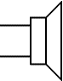

**Process Devices**

**Logic gates** are digital electronic devices that have one or more inputs. Logic gates have only two possible values (logic levels) for their inputs and outputs.

These are:

Logic ‘1’ – a high voltage

Logic ‘0’ – a low voltage.

A **truth table** shows the output for all possible input combinations for a logic gate.

Each logic gate has its own unique symbol and truth table.

**Points to remember**

For a light sensor (LDR) the output is high (logic 1) when it is light and low (logic 0) when it is dark.

For a temperature sensor (thermistor) the output is high (logic 1) when it is hot and low (logic 0) when it is cold.

**NOT Gate (inverter)**

Symbol 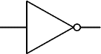 The output is the opposite of the input.

Truth table:

|  |  |
| --- | --- |
| input | output |
| 0 | 1 |
| 1 | 0 |

**AND Gate**

Symbol 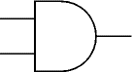

The output is only ‘1’ when **both** inputs A and B are ‘1’.

Truth table

|  |  |  |
| --- | --- | --- |
| Input A | Input B | output |
| 0 | 0 | 0 |
| 0 | 1 | 0 |
| 1 | 0 | 0 |
| 1 | 1 | 1 |

A

B

A

B

**OR Gate**

Symbol 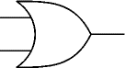

The output is ‘1’ if either A or B, (OR both) are ‘1’.

Truth table

|  |  |  |
| --- | --- | --- |
| Input A | Input B | Output |
| 0 | 0 | 0 |
| 0 | 1 | 1 |
| 1 | 0 | 1 |
| 1 | 1 | 1 |